**Mini Project Report on**



**Driver Drowsiness Detection**



**Submitted in partial fulfillment of the requirement for the award of the degree of**

**BACHELOR OF TECHNOLOGY**

**IN**

**COMPUTER SCIENCE & ENGINEERING**

**Submitted by:**

**Shashank Kothari**  **University Roll No.2017020**

***Under the Mentorship of***

**Mr. ANKIT TOMAR**

**Assistant Professor**



**Department of Computer Science and Engineering**

**Graphic Era (Deemed to be University)**

**Dehradun, Uttarakhand**

**January 2023**



**CANDIDATE’S DECLARATION**

I hereby certify that the work which is being presented in the project report entitled **“Driver Drowsiness Detection”** in partial fulfillment of the requirements for the award of the Degree of Bachelor of Technology in Computer Science and Engineeringof the Graphic Era (Deemed to be University), Dehradun shall be carried out by the under the mentorship of **Mr. Ankit Tomar, Assistant Professor**, Department of Computer Science and Engineering, Graphic Era (Deemed to be University), Dehradun.

SHASHANK KOTHARI 2017020

**Table of Contents**

|  |  |  |
| --- | --- | --- |
| **Chapter No.** | **Description** | **Page No.** |
| Chapter 1 | Introduction | **1-2** |
| Chapter 2 | Literature Survey | **3-4** |
| Chapter 3 | Methodology | **5-6** |
| Chapter 4 | Result and Discussion | **7-8** |
| Chapter 5 | Conclusion and Future Work | **9** |
|  | References | **10** |

**Chapter 1**

**Introduction**

In the following sections, a brief introduction and the problem statement for the work has been included.

* 1. **Introduction**

In today's rapidly evolving world, ensuring road safety remains a paramount concern. The risks posed by driver fatigue and drowsiness are significant, leading to a substantial number of accidents annually. These incidents have severe repercussions, causing injuries, loss of lives, and imposing substantial economic burdens. To tackle this pressing issue, advanced technologies and intelligent systems have been developed to detect and prevent driver drowsiness in real-time.

Our project is dedicated to the development of a robust and efficient system for detecting driver drowsiness. Through harnessing the capabilities of machine learning and computer vision, our objective is to create a dependable solution capable of accurately recognizing indicators of driver fatigue and issuing timely alerts to prevent potential accidents. Our overarching aim is to augment road safety, curtail the occurrence of accidents caused by drowsy driving, and safeguard the lives of both drivers and passengers.

**1.2 Problem statement**

The prevalence of drowsy driving poses a significant risk to road safety worldwide, resulting in a substantial number of accidents and fatalities. Existing solutions for detecting and preventing driver drowsiness in real-time are inadequate, highlighting the urgent need for a reliable and efficient system. A crucial challenge is to develop a driver drowsiness detection system that can accurately recognize fatigue signs and promptly alert drivers before potential accidents occur.

Current approaches to addressing drowsy driving suffer from limitations and inadequacies. Traditional methods, such as subjective self-assessment or fixed-time reminders, fail to consider individual variations in fatigue levels and may not provide timely warnings. Moreover, placing the sole responsibility on drivers to assess their own fatigue levels accurately and react appropriately is unreliable.

Hence, the objective of this project is to create an advanced driver drowsiness detection system that leverages cutting-edge technologies like machine learning and computer vision. The system will effectively identify and notify drivers experiencing drowsiness by monitoring crucial indicators such as eye closure duration, blink patterns, and head movements in real-time. The system aims to accurately classify driver states and enhance road safety significantly.

**Chapter 2**

**Literature Survey**

This chapter focuses on recent research conducted by various authors in the field of object detection, including humans, vehicles, tanks, and more, within surveillance videos. Surveillance is of increasing importance as it enables long-term tracking of objects in diverse environments. However, detecting and tracking objects in surveillance videos present several challenges, including varying illumination conditions, complex and dynamic backgrounds, and the presence of occlusions. Consequently, these models are primarily utilized in scenarios where clear detection of distinct human bodies or other objects can be achieved based on their dimensions, such as length, width, and height.

Researchers have proposed heterogeneous techniques for object tracking, detection, and identification in videos. Physiological parameters-based techniques focus on detecting drowsiness by monitoring drivers' physical conditions, including heart rate, pulse rate, breathing rate, respiratory rate, and body temperature. These biological parameters offer increased reliability and accuracy in drowsiness detection as they directly reflect the driver's physical state. Fatigue or drowsiness leads to changes in physiological parameters such as decreased blood pressure, heart rate, and body temperature. Drowsiness detection systems based on physiological parameters can identify these changes and alert the driver when they are approaching a sleep state.

In conclusion, this chapter reviews the recent advancements in object detection and tracking in surveillance videos.

**1) EEG-BASED DRIVER FATIGUE DETECTION**

EEG-based driver fatigue detection is an advanced method that utilizes electroencephalography (EEG) technology to monitor and identify signs of fatigue in drivers. By measuring the electrical activity of the brain through electrodes placed on the scalp, EEG enables the analysis of brainwave patterns associated with different mental states.

In the context of detecting driver fatigue, specific regions of the driver's scalp are equipped with EEG electrodes to capture brainwave signals. These signals are then processed and analyzed to detect patterns that indicate fatigue or drowsiness. This analysis involves extracting features such as frequency bands (e.g., alpha, theta) and assessing their changes over time.

To interpret the EEG data and classify the driver's fatigue level, machine learning algorithms are commonly employed. By training these algorithms with labeled EEG data from alert and drowsy states, they can learn to recognize patterns and make accurate real-time predictions.

**2) PULSE SENSOR METHOD**

The pulse sensor is mounted on the inner circle of the steering wheel, enabling heart pulse wave measurement even during single-hand driving. It consists of an infrared emitter and detector diode positioned side by side to accurately capture the pulse signal. By monitoring blood flow and oxygen levels, the sensor provides data for heart pulse rate analysis. Using HRV frequency domain software, fluctuations in oxygen levels are visualized, allowing for the identification of drowsiness. Decreased LF/HF ratio signifies drowsiness, enabling timely alerts to prevent accidents. Implementing pulse sensors and analyzing heart-rate variability effectively reduces accidents on the road.

**3) WEARABLE DRIVER DROWSINESS DETECTION SYSTEM**

A wearable driver drowsiness detection system is a portable and self-contained device that can be worn by drivers to monitor and identify signs of drowsiness. It incorporates a range of sensors and technologies to track physiological and behavioural indicators associated with fatigue and drowsiness.

These systems typically include sensors such as EEG sensors, EOG sensors, heart rate monitors, and accelerometers. These sensors capture data on brainwave activity, eye movements, heart rate, and physical movements of the driver.

By analyzing the real-time data collected from these sensors, the wearable system can detect patterns and changes in the driver's physiological and behavioural parameters that indicate drowsiness. This analysis is often performed using machine learning algorithms trained on a dataset containing labeled drowsy and alert states.

To prevent drowsy driving, the wearable device provides various types of feedback or alerts to the driver. These can include vibrating alerts, auditory warnings, visual cues, or even interventions like activating seat vibrations or adjusting the vehicle's climate control system.

**Chapter 3**

**Methodology**

Driver drowsiness detection is a crucial aspect in today's society. The objective of this project is to develop software capable of monitoring driver behaviour and handling alert messages and alarms. The system begins with a login screen, followed by the option to choose from live camera feeds or stored videos as input for detection. The data is then processed into frames to facilitate the detection process. Facial expressions and drowsiness are detected using the dlib library, with a threshold value set for drowsiness detection.

**1.Python**

Python is a widely used general-purpose, high level programming language. It was created by Guido van Rossum in 1991 and further developed by the Python Software Foundation. Python is a widely used high-level programming language known for its readability and efficiency. It enables quick development and seamless integration of systems.

**2.Dlib**

Dlib is an open-source library extensively used for computer vision and machine learning tasks. It offers a wide range of tools and algorithms for tasks like facial recognition, object detection, and image processing. Dlib's face detection and facial landmark detection capabilities are particularly valuable for this project.

**3.Opencv**

OpenCV is a comprehensive open-source library for computer vision, machine learning, and image processing. It provides functionalities for image and video analysis, including object and face identification. Integration with other libraries like NumPy enables efficient processing and analysis of OpenCV arrays.

**4.Imutils**

Imutils is a convenient Python library built on top of OpenCV. It simplifies common image processing tasks, especially in computer vision applications. Imutils offers user-friendly functions that streamline development processes.

**4.Tkinter**

Tkinter is a Python GUI framework that comes bundled with the Python standard library. It is a cross-platform framework, allowing applications to run seamlessly on Windows, macOS, and Linux. Tkinter leverages native operating system elements for visual rendering, ensuring a native look and feel.

.

Fig 3.1 Diagram for the project

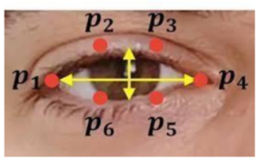

Fig 3.2 Eye co-ordinates of source

**Chapter 4**

**Result and Discussion**

The final GUI and the results are displayed below. The number of times a person in the video frame falls asleep is shown in the white box of the window. When the person closes their eyes for an extended period, an alarm rings to wake them up.

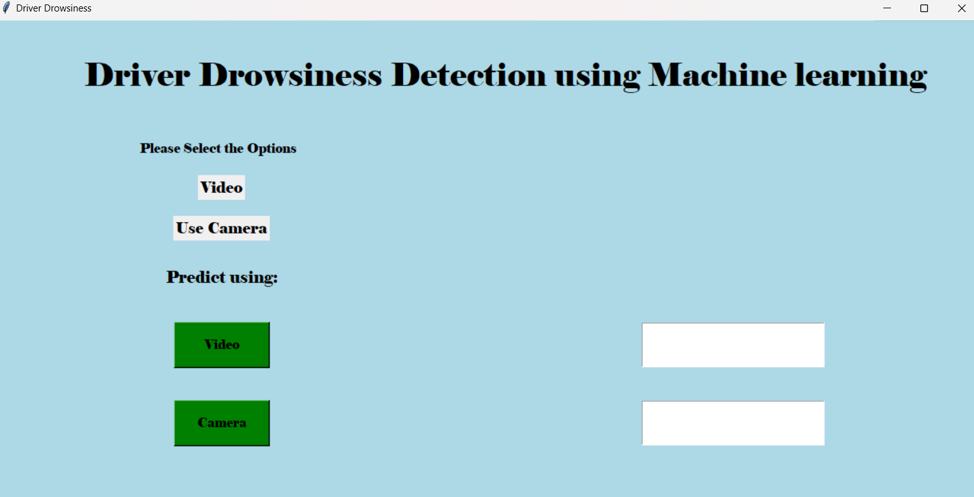

Fig 4.1 The GUI for the project

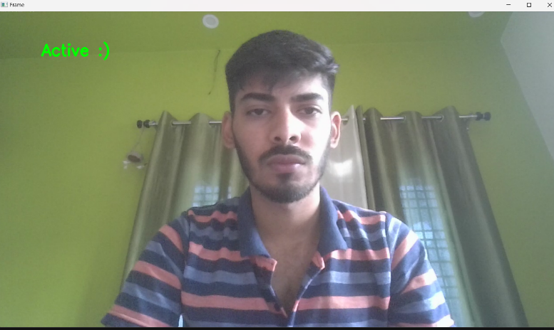

Fig 4.2 Video capture having the person active.

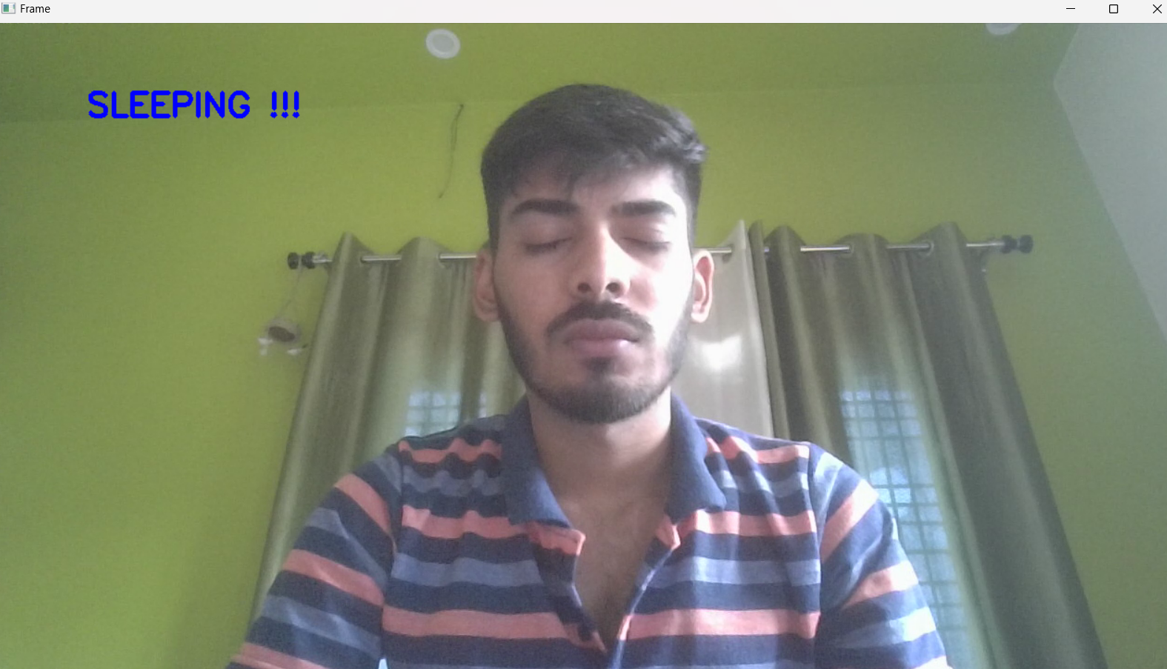

Fig 4.3 Video capture having the person asleep.



Fig 4.4 block showing no. of times alarm rang.

**Chapter 5**

**Conclusion and Future Work**

In conclusion, the development of our driver drowsiness detection system utilizing machine learning and computer vision techniques has shown promising results in accurately identifying signs of driver fatigue in real-time. By monitoring indicators such as eye closure duration, blink patterns, and head movements, our system has the potential to significantly reduce accidents caused by drowsy driving and safeguard the lives of drivers and passengers.

Moving forward, there are several avenues for future research and improvement in the field of driver drowsiness detection. Some potential areas for exploration include integrating physiological signals into the detection system, exploring deep learning approaches for more robust and accurate detection, developing driver-specific models to personalize the system, implementing real-time intervention strategies to prevent accidents, ensuring the system's robustness in varying environmental conditions, investigating long-term drowsiness prediction capabilities, and conducting real-world deployment and evaluation to assess its effectiveness in practical settings.

By addressing these future research areas, we can further enhance the performance and applicability of driver drowsiness detection systems, leading to improved road safety and the prevention of accidents caused by drowsy driving. It is our hope that these advancements will contribute to creating safer driving environments and reducing the potential risks associated with driver fatigue.

**References**

[1] Yaman Albadawi, Maen Takruri, Mohmmed Awad, “A Review of Recent Developments In Driver Drowsiness Detection Systems”, 2022 Multidisciplinary Digital Publishing Institute (MDPI), ISSN: 2205-2069, March 2022.

[2]  T. Vesselenyi, S. Moca, A. Rus, T. Mitran, B. Tataru, “Driver drowsiness detection using ANN image processing”, IOP conf. series: Materials science and engineering, DOI: 10..1088/1757-899X/252/1/012097, November 2017.

[3] Venkata Rami Reddy Chirra, Srinivasulu Reddy Uyyala, Venkata Krishna Kishore Kolli, “Deep CNN: A Machine Learning Approach Driver Drowsiness Detection Based on Eye State”, International Information and Engineering Technology Association, Vol. 33, No. 6, pp. 461-466, December 2019

[4] Z. Ahmad Noor Syukri, M. Siti Atiqah, L. Fauziana, and A. Abdul Rahmat, "MIROS crash investigation and reconstruction: annual statistical 2007-2010," 2012.

https://ieeexplore.ieee.org/abstract/document/8751886/

[5] D. Liu, P. Sun, Y. Xiao, and Y. Yin, "Drowsiness Detection Based on Eyelid Movement," in Education [1]Technology and Computer Science (ETCS), 2010 Second International Workshop on, 2010, pp. 49-52

[6] B. K. Savaş and Y. Becerikli, "Real Time Driver Fatigue Detection

Based on SVM Algorithm," 2018 6th International Conference on

Control Engineering & Information Technology (CEIT), 2018, pp. 1-4, doi: 10.1109/CEIT.2018.8751886.